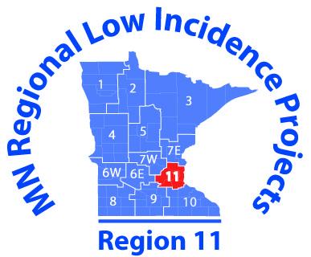

OT/PT EdCamp Guide February 9, 2018

The OT/PT Communities of Practice chose to use the EdCamp format for a combined meeting on February 9, 2018. Built on principles of connected and participatory learning, EdCamps strive to bring professionals together to talk about the things that matter most to them: their interests, passions, and questions. EdCamps allow everyone attending to be a presenter in their group. Our version is a bit of a modification from the original idea—because we only have two hours, we chose our topics ahead of time.
Rules of the Game
- Get out of the passenger seat!
- Be heard—participate!
- Share your passion and experience!

Topics for the EdCamp
- Therapists Role in Self-Regulation
- Service Delivery Models and IEP Documentation
- Coaching and Collaboration Across Settings
- Funding ideas for Equipment/resources

View videos to learn about EdCamps in general
https://www.youtube.com/watch?v=mp-3V6DAX_c
https://www.youtube.com/watch?v=pAqZksKIhus

What to Think About and Gather on Your Chosen Topic before Feb 9
What questions do you want answered about this topic?
What could you demonstrate with a quick “how to?”
What could you bring related to the topic to show others?
What experience could you share with others?

Anything goes—pose questions, share info, articles, books, websites, stories, demos—anything about the topic that would be helpful to others.

